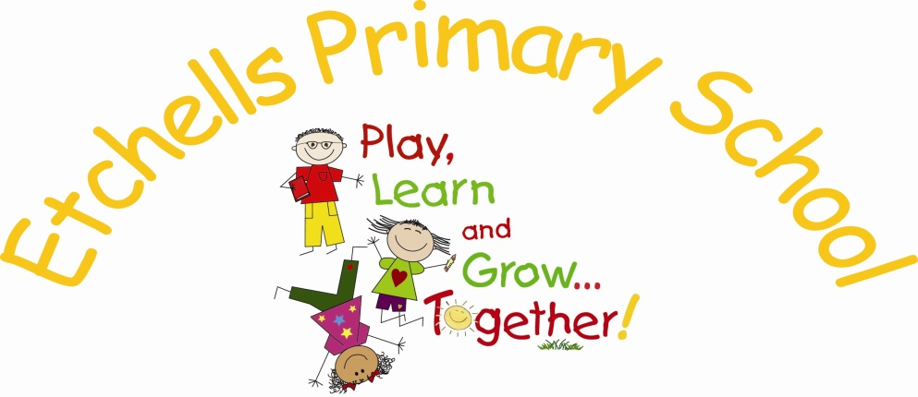

**School Uniform Policy**

**April 2022**

|  |  |  |  |
| --- | --- | --- | --- |
| **Date** | **Version** | **Update** | **Prepared by** |
| April 22 | 1.0 | Policy prepared for September 22 | J. Mallinson |
|  |  |  |  |
|  |  |  |  |

**Policy History**

**Principles**

It is our expectation that all children will wear clothing that is in keeping with a purposeful learning ethos. We also believe it is important that certain activities are facilitated by specialised and appropriate clothing when attending school, or when participating in a school-organised event outside normal school hours. We provide a complete list of the items required for children's school uniform in this policy and on our website. We ask for the co-operation of parents in following this policy and ensuring that pupils are appropriately dressed for all aspects of school life.

**Aims**

Our policy for children’s school uniform is based on the belief that a school uniform promotes:

* A sense of pride in the school
* Engenders a feeling of community and belonging
* Is practical and smart
* Identifies the children with the school
* Is not distracting in class
* Makes children feel equal to their peers in terms of appearance
* Is regarded as suitable and good value for money, by parents
* Has been designed with health and safety in mind

Since 19th November 2021, [Government guidance became law](https://www.gov.uk/government/news/new-rules-to-drive-down-cost-of-school-uniform-for-families)that states that schools should ensure that uniform costs are reasonable. We ask that the sweatshirt/cardigan is branded with the school logo, but all other items do not require branding, so are available from supermarkets, clothes shops, etc at competitive prices.

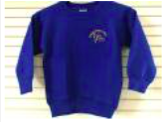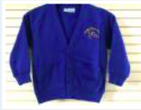

**Children need:**

**Summer Uniform- main uniform can be purchased from any store**

* Black or dark grey plain trousers,, shorts, skirt or pinafore dress
* Plain white polo shirt
* Blue and white checked dress, with white shorts underneath if required
* A blue sweatshirt or cardigan with the school logo - available from the school office
* Black, grey or white socks
* Black shoes or plain black trainers
* Waterproof coat
* Sunhat

**Winter Uniform- main uniform can be purchased from any store**

* Black or dark grey plain trousers, skirt or pinafore dress
* Plain white polo shirt
* A blue sweatshirt or cardigan with the school logo- available from the school office
* Black, grey or white socks
* Black or grey tights
* Black shoes or plain black trainers
* Waterproof coat

**PE Kit- to be purchased from any store**

*On the day that your child has PE can they attend school in their PE kit and wear their school sweatshirt or cardigan*

* Black or dark grey shorts
* Plain white t-shirt
* Plain black or white trainers for outdoor games
* Plain jogging bottoms or leggings for outdoor games in the winter
* All swimming costumes must be one piece/ swimming trunks/shorts baggy shorts not permitted. Any one with long hair must wear a swimming cap

**Forest school kit**

*On the day that your child has Forest School can they attend school in their Forest school kit and bring their boots or trainers in a bag*

* Plain coloured old tracksuit/ jogging bottoms/ leggings
* Plain coloured long sleeved t-shirt
* Plain coloured old sweatshirt/ jumper
* Gloves or sunhat depending on the season
* Wellington boots or old trainers

**Purchasing School Uniform**

School uniform can be purchased from the school office, please follow this link for current sizes and pricing and an email link to place the order:

<http://www.etchells.stockport.sch.uk/page/uniform-information/79958>

**Optional items**

* A small book bag for carrying homework diary, reading books, letters etc
* A drawstring PE kit bag for swimming/ Forest School. No large bags please

**Please make sure all items of clothing are clearly named**

**Jewellery**

Make up and fashion jewellery are not acceptable or appropriate for school. Standard watches may be worn but parents are reminded that pupils must be responsible for their own property and watches will be removed if they become a distraction during lessons. A single earring in each ear, ie. a small stud earring, may be worn by children with pierced ears but for Health and Safety reasons children will be expected to either remove their earrings or cover them with tape during PE sessions. Long hair must be tied back; nail polish and visible, temporary tattoos are not appropriate in school and should not be worn.

**Accessibility**

The governing body recognises the need to ensure that the uniform is affordable and will work with the school and the PTA to ensure schemes such as ‘pre-loved’ sales are in place and well publicised. The school will also ensure that parents and carers know about any local authority schemes that can provide school clothing grants or other help towards the cost of school clothing. ]

The governing body is committed to its obligations to accommodate reasonable religious or cultural requirements within the official school uniform and to ensure it is not discriminatory on the grounds of gender, race, religion or belief.

**Shoes**

Children spend a long time in school and we want them to have healthy, happy feet! Children of all ages enjoy running and playing on the climbing equipment; shoes should be flat and provide good foot support. They should be black in colour. Boots should not be worn in school and in winter children should bring indoor shoes if walking in boots. Trainers, flip-flops and 'crocs' are not appropriate footwear in school.

**Sun Protection**

We are very keen to promote a healthy exposure to the sun. Caps should be worn in sunny weather.