**

**POSITIVE RELATIONSHIPS**

**POLICY**

**February 2024**

**Policy History**

|  |  |  |  |
| --- | --- | --- | --- |
| **Date** | **Version** | **Update** | **Prepared by** |
| April 2014 | 1.0 | Policy reviewed | C. Beddows |
| Sept 2015 | 2.0 | Updated and shared with Govs Teaching and Learning Committee | C. Beddows |
| Sept 2016 | 3.0 | Updated, waiting for Governor approval | C. Beddows |
| Sept 2017 | 4.0 | Updated, approved by Headteacher and staff; waiting for and Governor approval | J. Malone |
| January 2019 | 5.0 | Updated, approved by Headteacher and staff; waiting for and Governor approval | P. Cope |
| January 2020 | 6.0 | Updated, approved by Headteacher and staff; waiting for and Governor approval. COVID measures put into policy | P. Cope |
| January 2021 | 7.0 | Updated, approved by Headteacher and staff; waiting for and Governor approval. COVID measures put into policy | P. Cope |
| January 2022 | 8.0 | Updated, approved by Headteacher and staff; waiting for and Governor approval. | P. Cope |
| January 2023 | 9.0 | Change of name to positive relationship policy, updated with new aims. Guidance gathered from staff, parents and children. | P. Cope |
| September 2023 | 10.0 | Changes to the policy from the Paul Dix reading and INSET delivered to staff | P.Cope |
| February 2024 | 10.1 | Checked for any amendments to share with the governors. | P.Cope |

Our aims are:

* To ensure that the Core Values and Bee Rules are embedded and followed within school.
* To have a consistent and fair system in place where the children feel that their thoughts are listened to and that they are valued.
* To form positive relationships within the school community, where a sense of shared responsibility for behaviour is taken.
* To create a culture of acceptance and tolerance for all members of the school community.

This will be achieved by:

* The children receiving Dojos for following the Bee Rules and demonstrating a quality from our Core Values.
* Regular reminders to staff and children of the behaviour expectations at school, ensuring that the views of the school community are taken into account.
* Annual review of the Bee Rules by all members of the school community.
* The Bee Rules to be present in all classrooms and in key areas across the school.
* The training and induction of staff to ensure that a consistent approach is used across the school.
* Monitoring of the effectiveness of the Positive Relationship Policy, reviewing Reflection time and Dojo awards that are given.

It is vital that all staff ensure that the children feel happy, safe and secure at school; this will form the best foundation for the children to be successful with their learning. At Etchells, we achieve this by ensuring that we develop strong and respectful relationships with the children. Our adults promote the values and expectations and implement a defined and consistent reward system. At Break and Lunchtimes, children are encouraged and helped with play, involving adults to model positive behaviour during various games.

When behaviour is shown that is not in keeping with the standards of behaviour expected at Etchells, the child will be encouraged using positive reinforcement. The child will also have it explained to them in a clear and concise manner which behaviours we would not expect to see. For some children it would be appropriate to implement a bespoke behaviour plan. This is completed in conjunction with parents.

A log of incidents that require reflection is kept by Mr Cope, Deputy Headteacher. These are shared with parents in order for there to be continuity between home and school. All reflection forms are stored safely and a log is kept. This is analysed every term to form a better understanding of how behaviour looks across the school and is reported to Governors.

**Core Values**

Underpinning all that we do at Etchells are our Core Values. These are drivers for behaviour in school and the children are encouraged to demonstrate these values throughout the school day. Dojo awards are given to children who exemplify these values.

**Bee Rules**

We expect our ‘Bee Rules’ to be followed by all members of the school community, both inside and outside of the classroom. These are reviewed on an annual basis and the children are regularly reminded to follow these. Please see below for our ‘Bee’ Rules:

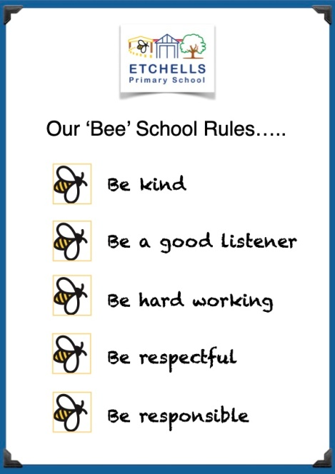

**Praise**

Positive reinforcement is at the heart of all behaviours at Etchells. Adults who work with the children focus on the positives and this behaviour is rewarded. These are all age and developmentally appropriate for the children with each key phase having specific rewards in place. Alongside rewards, we praise intrinsically positive behaviour in the classroom and will recognise this when it is demonstrated.

**EYFS Phase**

* Verbal praise
* Stickers and stamps
* VIB (very important bee!) chosen each day, badge worn for the day
* Star of the week - children given badge to keep and certificate presented in EYFS assembly on Fridays.
* 2 core value certificates awarded per class each week presented in EYFS assembly on Fridays.
* Children move their name onto the star for 'star of the week' or onto 'VIB' each day.
* Prize box
* Challenge stamp awarded onto individual children's challenge chart for each provision area challenge completed, prize when chart is completed.

**KS1**

* Class Dojos
* Stickers and stamps
* Verbal praise
* Star of the week presented in Fridays assembly
* Table Dojos

**KS2**

* Class Dojos
* Verbal Praise
* Stickers and stamps
* Star of the week presented in Fridays assembly

If a child’s behaviour has been exceptional or they have completed a piece of work which has impressed the teacher then they may be brought to a member of the Senior Leadership Team to receive a special award.

Dojos will be awarded to all children for demonstrating one of the Core Values or following the ‘Bee’ Rules. This will be for the children who are going ‘above and beyond’ the normal expectations in the classroom. We have high expectations of consistently good behaviour and behaviours for learning.

**What our children say about behaviour at Etchells**

It is vital that we understand how the children perceive behaviour and act accordingly if they believe the behaviour system not to be fair. Our system is consistent and clear across all areas of the school. In January 2023, pupil voice was gained for us to better understand what the children thought behaviour looked like, here are some points that the children made:

* At Etchells, we cheer people up when they are feeling sad.
* We demonstrate a positive mind-set
* We keep our hands and feet to ourselves
* Teachers give enough warnings so that children will learn from this.
* We listen to staff
* We focus on the positives rather than the negatives.
* We treat everyone with equality
* We treat people the way that we want to be treated.
* We help other children and the staff

**As this is the views of our pupils, we strive to ensure that all behaviour and relationships in school reflect this.**

**Communication with Parents**

All parents are invited to sign up to Class Dojo. On Class Dojo, direct notifications are sent to parents when a child receives a dojo. The children are awarded a Dojo for either demonstrating the Core Values or Following the ‘Bee Rules.’ These are the only reasons that the children will receive a Dojo.

**Behaviour expectations**

A key message that we deliver at Etchells is: ‘That is how we do it here,’ to reinforce the positive behaviour that the children are demonstrating. This is a reminder to the children of the high expectations that we have of behaviour here at Etchells.

If behaviour not up to that high standard, the children are reminded with the statement: ‘That is not how we do it here.’ If this reminder does not change the behaviour, the child may be given a warning and their name placed in the class clipboard, see Appendix 1 for our reminder system. The children will receive three warnings: a reminder, a caution and a final chance. If the behaviour has not changed at that point then they will have a time in with phase leaders.

If there are any incidents of serious incidents (see Appendix 1, under reflection), this will result in a reflection time being completed by one of our Senior Leaders (See Appendix 2.) These will be printed and sent home with the children so that the parents/guardians can see the words that the children have used to explain the situation. There is a clear system in place for what happens after each reflection and a table that explains the next steps (see appendix 3) **At Etchells, we have a culture that does not tolerate any prejudice or discrimination.**

In the EYFS we use a Behaviour Chart with visual symbols to help some children to understand their behaviour and to see if there is a pattern of behaviour. When they follow our bee rules they receive a smiley face on their chart. If they show behaviour not in keeping with our standards the space will be left blank so that the positives can be focused on.

**Child on Child Abuse**

This form of abuse is when there is any kind of physical, sexual, emotional or financial abuse or coercive control exercised between children/young people both on and offline. At Etchells, all staff understand the importance of challenging inappropriate behaviours between children/young people. Downplaying certain behaviours, for example dismissing sexual harassment as “just banter”, “just having a laugh”, “part of growing up” or “boys being boys”; or not recognising that emotional bullying can sometimes be more damaging than physical harm and should be taken equally seriously. Stopping harm and ensuring immediate safety is Etchells first priority.

**Restorative Approach**

It is a firm belief that there is a reason behind all behaviours that are shown. At Etchells, when dealing with any relationships we adopt the restorative approach. The definition of Restorative Approaches is: ***Restorative Approaches/Practice describes a way of being. It promotes active thinking about how we build our relationships, how we work to keep them healthy and how we can repair them when there has been conflict.***

Restorative Practice is relevant to us all. It supports us to connect with each other as fellow human beings, guiding us with our interactions. It can help us to consider how our actions and responses affect our relationships, whether these are relationships at work or at home.

When reflecting on how our actions impact others, we use the Restorative Triangle. This shows that thoughts, emotions and behaviour are drivers for each other. Our thoughts can affect how we feel and how we act to those around us. Our feelings can affect how we think and what we do. Our actions can affect how we think and how we feel.

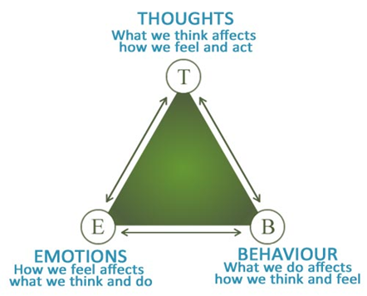It is important that the children realise that all actions have an impact on those around them. At Etchells, we equip the children with strategies to repair relationships after conflict.

**Appendix 1- Reminder system**

|  |  |  |
| --- | --- | --- |
| **Steps** | **Behaviours shown** | **Who is responsible?** |
| Reminder | Child day dreaming, looking around, talking (non-disruptive), talking, distracting others, slow to complete work, calling out, rudeness to staff, throwing small equipment, continual talking, refusal to follow instructions. | Class teacher |
| Caution |
| Final Chance |
| Time in | Follow Steps 1-3 unless:  Leaving the classroom,  Refusal to come in from  playground | Phase Leader |
| Reflection | Follow steps 1-4 unless:  Deliberate violence towards a  Child/adult in the classroom  Racist incidents  Upturning furniture  Swearing directly at an adult | Member of SLT (See timetable) |

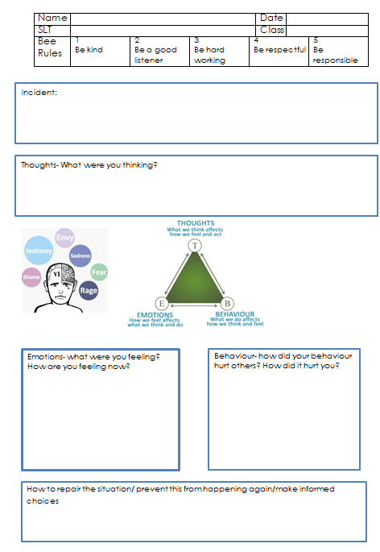**Appendix 2- Reflection Sheet**

**Appendix 3- Behaviour ladder**

|  |  |
| --- | --- |
| Step 1 | Reminder given to the child and name put in clipboard |
| Step 2 | A caution is given to the child and child is spoken to by class teacher. Their name is ticked inside the clipboard. |
| Step 3 | The child is given a final chance. The class teacher will speak to the child about their behaviour and what the next steps are if it continues. |
| Step 4 | Time in. The child will be taken immediately to have some time in with the phase leader of the phase that they are in. After the child has completed their time in they will then have a follow up discussion with the phase leader and class teacher. |
| Step 5 | 20 minute period of reflection with member of the Senior Leadership Team issued at lunchtime or in the afternoon to reflect on their behaviour. In the case of children who have a school dinner, their wrist band will be collected and the meal reserved. Children will complete a Reflection sheet identifying which of the school rules they are breaking and these forms will be kept by the Deputy Headteacher. At these sessions a decision will be made by the member of the Senior Leadership Team as to whether the behaviour warrants being placed on report. If this is the third time a child has attended they will be automatically placed on report. Parents to be informed through the sheet being printed off for them if there child has attended a session to reflect on their behaviour. At the second incident of reflection the deputy headteacher will ring the parent to inform of the next steps. |
| Step 6 | If a child has been placed on report and then had three further reflections the Senior Leadership Team will meet to discuss if internal exclusion procedures need to be applied. |
| Step 7 | If a child has received an internal exclusion and is subsequently placed on report again then the Senior Leadership Team will meet to discuss if internal/external fixed term exclusion procedures are applied. |