
Etchells Skills and Knowledge Progression

Subject: Music

 | EYFS |  | Key Stage 1 |  | Key Stage 2
 | Nursery | Reception | Year 1 | Year 2 | Year 3 | Year 4 | Year 5 | Year 6
Rhythm Work | Knowledge | Knowledge | Knowledge  To know what these rhythms represent  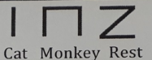 | Knowledge  To know what these rhythms represent  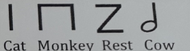 | Knowledge  To know what these rhythms represent  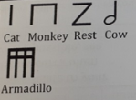 | Knowledge  To know what these rhythms represent  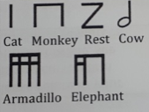 | Knowledge  To know what these rhythms represent  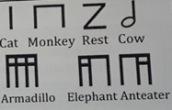 | Knowledge  To learn the correct names for all note values from a semiquaver to a semibreve  If confident, add compound rhythms
 | Skills | Skills | Skills  To play these rhythms on untuned percussion  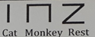 | Skills  To play these rhythms on untuned percussion  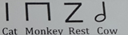 | Skills  To play these rhythms on untuned percussion  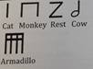 | Skills  To play these rhythms on untuned percussion | Skills  To play these rhythms on untuned percussion  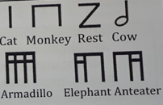 | Skills  To play these note values on untuned percussion
Play and perform in solo and ensemble contexts | Knowledge | Knowledge | Knowledge | Knowledge | Knowledge | Knowledge | Knowledge | Knowledge
 | Skills | Skills | Skills | Skills  To speak chants and rhymes  To use their singing /performing face  To sing as a class and in assembly  To play tuned and untuned percussion instruments | Skills  To play in class ensemble using tuned and untuned percussion  To sing regularly, working on dynamic contrasts | Skills  To play in class ensemble with a sense of what’s going on in the whole group  To sing contrasting styles of songs using different tempo and dynamics | Skills  To play in a class ensemble with increased leadership skills and have a sense of what’s going on in the whole group  To perform/sing a solo  To sing echo and part songs | Skills  To perform/sing a solo with increased confidence and control  To sing in parts, 2 & 3 part rounds  To make all performances as expressive as possible
Improvise and compose music | Knowledge | Knowledge | Knowledge | Knowledge  To recognise the structure = binary AB  To understand Texture = thick/thin  To understand Timbre = different sounds  To recognise Notation = use of flash cards (graphic, picture scores) | Knowledge | Knowledge | Knowledge  To be aware of different textures and timbres | Knowledge
 | Skills | Skills | Skills | Skills  Create a simple binary piece of music that demonstrates understanding of the above elements. | Skills  To improvise using all known rhythm tags  To compose a piece in binary form AB | Skills  To improvise using all known rhythm tags  To compose a piece in binary form ABA | Skills  To improvise and then develop a composition from the improvisation | Skills  Create a composition from a given or chosen stimulus
Listen with attention to detail and recall sounds with increasing aural memory. | Knowledge | Knowledge | Knowledge | Knowledge | Knowledge | Knowledge | Knowledge | Knowledge
 | Skills | Skills | Skills | Skills  To recognise brass  To recognise strings  To recognise changes in dynamics & tempo | Skills  To recognise all four families of the orchestra  To recall a simple tune from memory  To sing a song from memory | Skills  To pick out individual instruments in a piece  To clap back a two bar rhythm pattern  To sing a song from memory | Skills  Clap back a four bar rhythm pattern  Sing or clap back a main theme from a listening exercise | Skills  To clap back a four bar rhythm pattern  To sing and clap back a main theme from a listening exercise
Use and understand staff and other musical notation. | Knowledge | Knowledge | Knowledge | Knowledge | Knowledge  To understand Notation middle C-A | Knowledge  To understand notation middle C-C’ | Knowledge | Knowledge
 | Skills | Skills | Skills | Skills | Skills  To use rhythm flash cards and/or graphic scores | Skills  To use rhythm flash cards and/or graphic scores | Skills  To notate compositions using the most appropriate method applicable | Skills  Notate compositions using the most appropriate method applicable
Appreciate and understand a wide range of high quality live and recorded music | Knowledge | Knowledge | Knowledge | Knowledge | Knowledge | Knowledge | Knowledge | Knowledge
 | Skills | Skills | Skills | Skills  To listen to live music | Skills  To listen to a selection of different pieces of music  To listen to live music | Skills  To talk about how music makes you feel. show understanding of the structure, tempo and dynamics  To listen to live music | Skills  To write/talk about music, show understanding of the inter-related dimensions  To listen to a variety of composers/traditions  To respond to live music | Skills  To write/talk about music, show understanding of the inter-related dimensions and make comparisons across genres  To respond to live music
Develop an understanding of the history of music | Knowledge | Knowledge | Knowledge | Knowledge | Knowledge  To relate to your history curriculum where possible. | Knowledge  To relate to your history curriculum where possible. | Knowledge  To relate to your history curriculum where possible. | Knowledge  Relate to your history curriculum where possible
 | Skills | Skills | Skills | Skills | Skills | Skills | Skills | Skills

