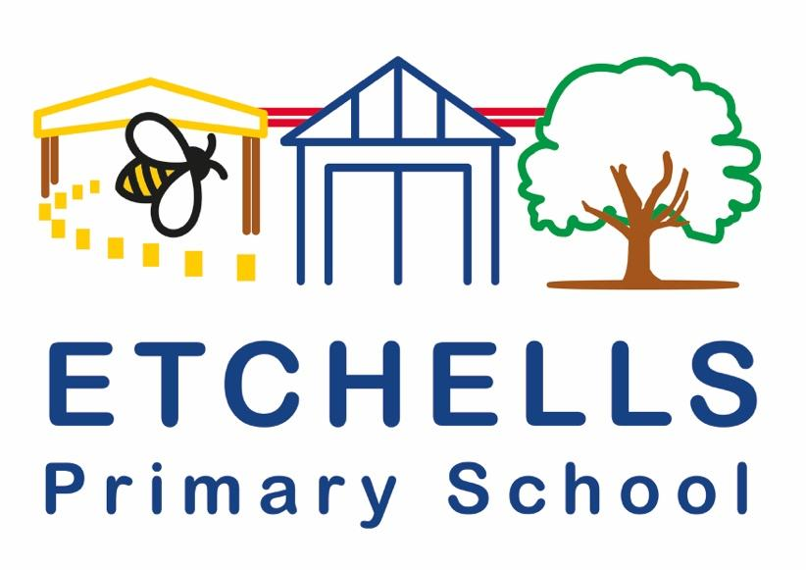

**English POLICY**

**April 2024**

**Policy History**

|  |  |  |  |
| --- | --- | --- | --- |
| **Date** | **Version** | **Update** | **Prepared by** |
| 24/9/24 | 1 |  | Claire Wilson |
|  |  |  |  |
|  |  |  |  |

**1. Aims**

At Etchells Primary School we aim to develop pupils’ English abilities within an integrated programme of Speaking and Listening, Reading, Writing, Spelling, Grammar and Punctuation. Pupils are given a broad and balanced approach to the teaching of English, with opportunities to consolidate and reinforce skills taught across the curriculum.

This policy should be read alongside the new National Curriculum in England (published September 2013) and other documents from the Standards and testing Agency. The statutory requirements for the teaching and learning of English are laid out in the National Curriculum (2014). The curriculum states:

*The overarching aim for English in the national curriculum is to promote high standards of language and literacy by equipping pupils with a strong command of the spoken and written word, and to develop their love of literature through widespread reading for enjoyment. The national curriculum for English aims to ensure that all pupils:*

* read easily, fluently and with good understanding
* develop the habit of reading widely and often, for both pleasure and information
* acquire a wide vocabulary, an understanding of grammar and knowledge of linguistic conventions for reading, writing and spoken language
* appreciate our rich and varied literary heritage
* write clearly, accurately and coherently, adapting their language and style in and for a range of contexts, purposes and audiences
* use discussion in order to learn; they should be able to elaborate and explain clearly their understanding and ideas
* are competent in the arts of speaking and listening, making formal presentations, demonstrating to others and participating in debate.

**2. Spoken Language:**

The National Curriculum states that pupils should be ‘taught to speak clearly and convey ideas confidently in Standard English.’ They should:

* justify ideas with reasons
* ask questions to check understanding
* develop vocabulary and build knowledge
* negotiate
* evaluate and build on the ideas of others
* select the appropriate register for effective communication
* give well-structured descriptions and explanations
* speculate, hypothesise and explore ideas
* organise their ideas prior to writing

At Etchells Primary School we encourage our pupils to speak clearly and confidently and articulate their own views and opinions. We teach the children to express themselves orally in an appropriate way, matching their style and response to audience and purpose.

We support the development of our pupil’s speech and language, across the curriculum. Including:

* planning activities which encourage full and active participation by all children, irrespective of ability
* having provision in place for children with specific speech and language and auditory problems and seeking specialist help where appropriate
* using school plays, assemblies and performances to give children the opportunity to speak in public
* planning events within the community
* facilitating class debates and discussions
* embedding the use of talk partners/group work and discussion within all lessons
* using drama and role play activities
* carefully planning PSHE, circle time and beliefs and faith activities where children can express their own opinions

Teachers use the EPS Speaking and Language Progression document to assess pupils’ speaking and language abilities and to plan activities to support the development in this area.

**3. Phonics**

Our children are provided with a variety of opportunities to develop and extend their phonics skills in and across Nursery, Reception and Key Stage 1. This is also continued into Key Stage 2, where necessary, to support those children who do not yet have the phonic knowledge and skills they need.

Phonics at Etchells:

* We use our own created synthetic phonics scheme. It follows the systematic approach laid out in Letters and Sounds (DfE 2007), adapted as necessary to ensure all children can develop their phonic knowledge effectively. Resources are used from Jolly phonics, Smart Kids and twinkl to supplement delivery. A range of standalone resources such as large graphemes, phonic phase games are also used. Miss Hobson is a level 7 SPLD teacher and monitors the phonic scheme to ensure staff are trained and delivering the scheme in an effective, systematic way.
* Reading books are matched to the taught phonic phases and children are provided with decodable individual reading books, at the phonic phase they are accessing, until they can read beyond orange band.
* Discrete, 20-minute phonics sessions take place daily across Reception and Key Stage 1. They follow the structure of ‘Review, Teach, Practise, Apply’ to ensure that children are consolidating phonic knowledge and skills over time and are able to apply them in context. Consequently, wherever possible, links between phonics knowledge and understanding are made to learning in both Reading and Writing. These lessons proceed at pace and incorporate a wide range of practical and interactive activities to engage the children. These activities are carefully chosen to ensure that children develop their skills in aural discrimination and phonemic and rhyme awareness, blending and segmenting as well as grapheme phoneme correspondence.
* Children are taught in groups according to their phonic ability.
* Children in Key Stage 1 will still take part in a daily, discrete session at the stage which is suited to their needs, led by a teacher. Additional interventions and follow up sessions led by a TA may also be put in place.
* Reading strategies are taught alongside phonic skills at all times used to promote independent fluent readers.

Phonics intervention:

* Children who still need extra support to develop their phonic knowledge across Key Stage 1 and 2 are identified and targeted for intervention. There are a range of intervention strategies the school uses and the most appropriate one is selected once a child’s needs have been assessed.
* From Reception if a child is not making expected progress, they are targeted with systematic intervention to encourage them to make progress and close the gap. Phonological awareness is key and resources such as Smart Chute, Oral blending and segmenting are utilised to encourage children to develop these vital skills.
* The Nessy programme is also used as an intervention to develop phonic skills. Children at the very early stages of phonic development access the Hairy Phonics programme. Children at a more advanced stage access Nessy reading and spelling. Both these interventions are used at home and school.
* If a pupil continues not to make expected progress, Bear Necessities and Dancing Bears are used as a reading intervention in a 1 to 1 environment. This starts from Reception.
* As children move into Key stage 2 Nessy and Dancing Bears continue to be used as a phonic intervention, depending on the needs of the child. If appropriate Word Hornet or Toe by Toe is used as a 1-1 reading and spelling intervention for pupils still requiring further support.
* In Key Stage 2, if a pupil, following suggested intervention, fails to secure progress they are screened for phonological awareness, using the Sound Linkage programme. A programme of activities to develop missing skills is put in place.
* In Key stage 2 if, despite targeted intervention, phonic skills appear not to be acquired or applied a pupil is screened for dyslexia using “The Dyslexia Portfolio” battery of tests. A range of strategies to support the needs of the child are then created such as 1-1 sessions with Miss Hobson, taught use of a Spell Checker, Ace dictionary or laptop. If necessary, other supportive technologies are taught such as speech to text software.

**4. Reading**

The National Curriculum states that pupils should be taught to read fluently, understand extended prose and be encouraged to read for pleasure. Reading is singled out as extremely important since through it, ‘pupils have a chance to develop culturally, emotionally, intellectually, socially and spiritually’. Reading allows pupils to ‘acquire knowledge’ and to ‘build on what they already know’.

The 2014 curriculum divides reading into two strands:

* word reading and decoding
* comprehension

Reading at Etchells Primary School:

Our whole school approach is to have a ‘Reading rich’ curriculum, this includes:

* supporting children to develop a love of books and reading
* supporting children to engage in speaking, listening and responding
* enabling children to share in the reading process with an experienced reader
* supporting children to develop a love of books and reading
* promoting independent reading

Some pupils receive targeted interventions and attend pre reading sessions, where extra support is needed in decoding and comprehension as our ultimate goal is that all pupils:

* learn to read easily and fluently through daily phonics in Key Stage 1 and continuing in Year 3
* read widely through our use of differing class texts and high-quality books in classrooms
* read for pleasure using reading partners, quiet reading time, listening to an adult read and class audio books
* read to find information across the curriculum

How reading is taught at Etchells Primary School:

Across school, reading is taught through whole class reading sessions, focussing on decoding and comprehension. Alongside this, and where appropriate, children across school are heard reading weekly with an adult. Etchells has a diverse community with 47% of children speaking English as an additional language and 12.5% pupil premium, for this reason, our reading structure has been carefully developed and sequenced to support vocabulary acquisition and oracy.

Comprehension:

* 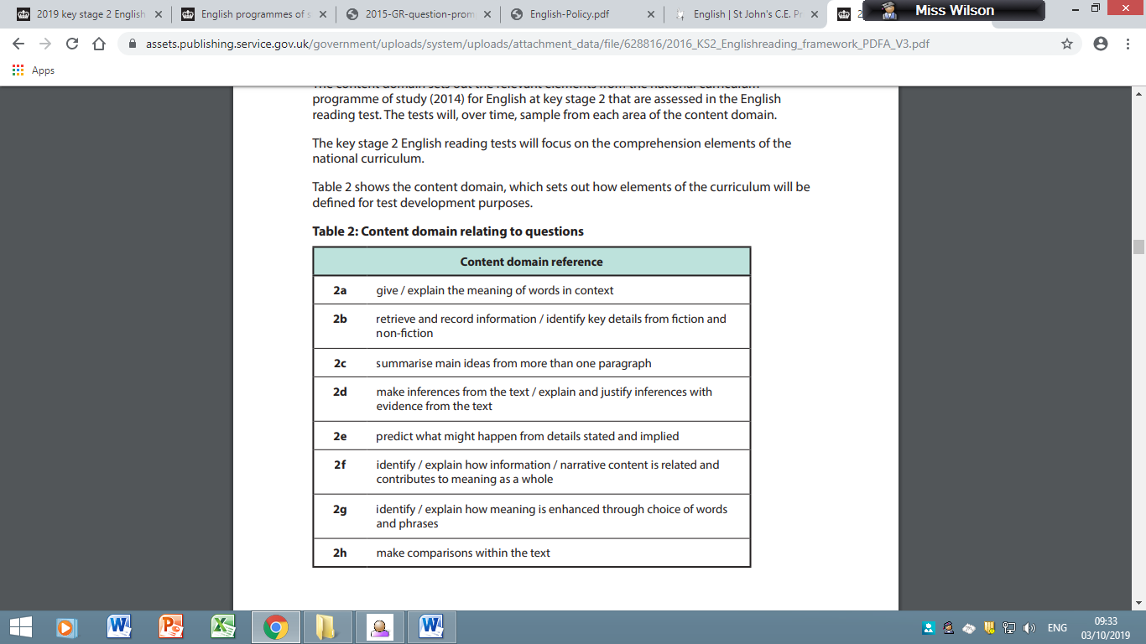Alongside the teaching of decoding, whole class reading is taught using the content domain. The content domains set out the relevant elements from the National Curriculum programme of study (2014) for English at key stage 2 that are assessed in the English reading test. The content domain focuses on the comprehension elements of the National Curriculum.
* In KS2, the children have 5 discrete comprehension lessons a week focussing on learning the skills needed to understand a text (KS1 5 over a two-week period). As a school, we use the Scofield and Sims Comprehension Complete Series. This is an essential companion for teaching reading comprehension which is written by a team of expert authors, it provides everything needed to develop the individual comprehension skills identified in the National Curriculum, alongside the broader vocabulary and background knowledge required for effective reading comprehension.

The structure of reading at Etchells:

1. Orientation/introduction to the text
2. Vocabulary - etymology of the word (prefix/suffix
3. Vocabulary - making connections (synonyms/antonyms)
4. Model and Mirror - explicit teaching of how to answer comprehension questions.
5. Comprehension - independent application.

* Content domain success criteria ladders are used to support children with answering comprehension questions focussed on the different domain areas:

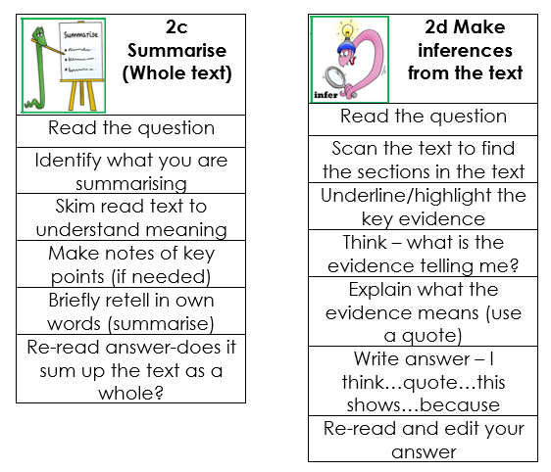

Promoting Reading at Home:

* In Reception, the children are provided with Sound Books, sharing phase 2 graphemes. This helps support rapid phoneme grapheme correspondence. Jolly Phonic actions are taught to encourage recall. They use given letter packs to create words to read and spell.
* In Reception, sight word packs are also sent home to encourage rapid sight word recognition. These match the phonic phase the child is working at.
* Once the pupil can recognise a range of phase 2 graphemes and read cv or vc words they are given an individual decodable reading book to take home.
* Throughout Reception and KS1 Children take home fully decodable books in line with their phonics ability and reading level. For some children this continues into Key stage 2
* Children reading beyond the orange band of books no longer require their reading to be tightly phonic linked. The books they access follow the school book banding system.
* All children have the opportunity to take home a book to promote reading for pleasure from the library or their class library.

**5. Writing**

The National Curriculum states that pupils should:

* develop the stamina and skills to write at length
* use accurate spelling and punctuation
* be grammatically correct
* write in a range of ways and purposes including narratives, explanations, descriptions, comparisons, summaries and evaluations
* write to support their understanding and consolidation of what they have heard or read

The 2014 Curriculum divides writing skills into two strands:

* transcription (spelling and handwriting)
* composition (articulating ideas in speech and writing)

We recognise that both these elements are essential to success and we support the acquisition of both sets of skills. We understand that these areas are clearly linked to the other aspects of English learning: speaking and listening, reading, spelling, grammar and vocabulary and we develop the child’s growing ability to construct and convey meaning in written language through carefully planned activities and opportunities.

During their time at Etchells Primary School, the children learn to write for different purposes and audiences and across a variety of fiction and non-fiction genre, including:

* Fiction:
* Stories
* Diaries
* Play scripts
* Letters
* Non-fiction:
* Reports
* Recounts
* Explanations
* Instructions / Lists
* Arguments / Persuasive
* Letters

Through experience of different types of writing, we enable children to:

* derive an interest and pleasure from writing
* express their feelings in writing
* show logical thought in planning and editing
* be able to direct and instruct through writing
* write for a clear purpose
* write for a variety of audiences
* transmit information
* write coherently and imaginatively

To achieve this, we:

* support children to develop their gross and fine motor skills to allow competency with a range of mark making tools
* provide a variety of stimuli to engage all learners
* model a range of examples of different types of writing
* give feedback, support and encouragement
* use record keeping and assessment to monitor progress and set targets
* encourage independence and confidence through the development of skills and by providing enriching opportunities
* provide opportunities to write across the curriculum in other subjects such as Science, Geography and History
* celebrate children’s written work by displaying it throughout the school

**A unit of writing at Etchells:**

* At Etchells we have created a bespoke approach for Writing lessons. As mentioned above, this is due to the diverse nature of our school and is tailored to meet the needs of our EAL, PP and SEND pupils.
* Much of our planning comes from Jane Considine Writing Unit Plans, which has a very specific approach to writing lessons, using a mixture of immersion days and sentence stacking- which support the development of vocabulary. These units are mostly booked based focussing on bringing the elements needed to write to life with real life experiences.
* Following a Jane Considine unit, teachers then plan and deliver a follow up unit which focuses on depending the children’s understanding of grammar features appropriate to each year group. Teachers’ planning includes a wide variety of activities to engage the children, including:
* shared reading
* text interrogation/creating success criteria
* DEAL
* vocabulary generating
* teaching of grammar and punctuation objectives
* modelled and shared writing
* short bust writing
* planning
* writing
* self and peer editing
* Lessons are differentiated using the Etchells learning challenges below. Key vocabulary is highlighted and discussed during the lesson. As well as this, opportunities are given for peer and self-assessment. 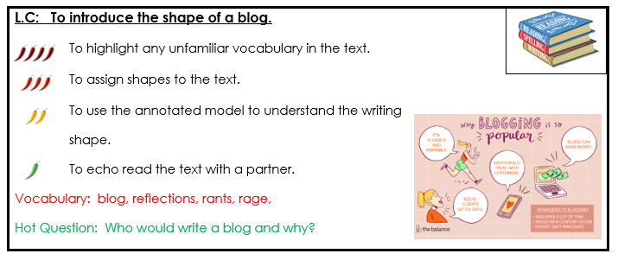
* At Etchells we understand the importance of and place a great emphasis on proofreading and editing as being a crucial element of the writing process, as such, we have developed a consistent approach to proof reading which is used across school. This is accompanied by proof reading ladders which are used to support the children’s independence.

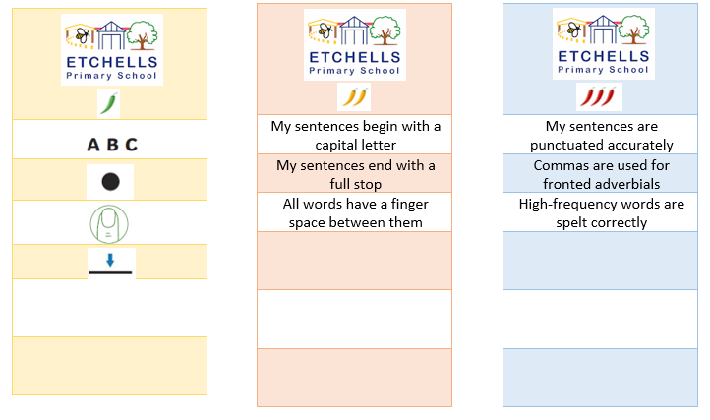

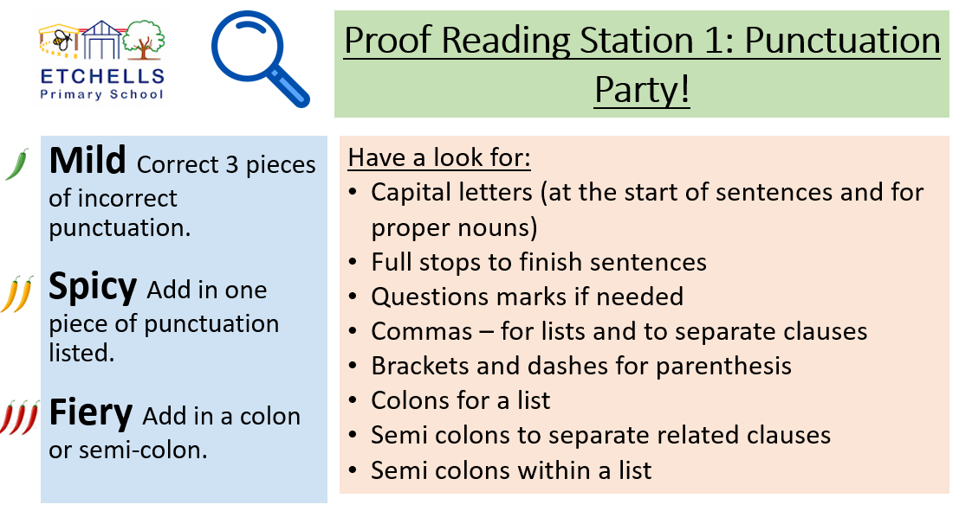

**Spelling, Punctuation and Grammar (SPAG)**

The National Curriculum makes it clear that learning vocabulary is the key to ‘learning and progress across the curriculum,’ since it allows our children to access a wider range of words when writing and to understand and comprehend texts efficiently. It states that…o*pportunities for teachers to enhance pupils’ vocabulary arise naturally from their reading and writing. As vocabulary increases, teachers should show pupils how to understand the relationships between words, how to understand nuances in meaning, and how to develop their understanding of, and ability to use, figurative language. They should also teach pupils how to work out and clarify the meanings of unknown words and words with more than 1 meaning.*

At Etchells Primary School the planning, teaching and learning of spelling, punctuation and grammar begins in EYFS and continues in Key Stage 1 and 2 with the National Curriculum document and using Spelling Shed. The Spelling, vocabulary, grammar and punctuation glossary in the National Curriculum statutory appendices - on spelling, vocabulary, grammar and punctuation - gives an overview of the specific features that should be included in teaching the programmes of study. Spelling, grammar and punctuation skills are integrated into writing units and, in some instances, taught in separate lessons as a review.

How spelling is taught at Etchells:

* Spelling Shed is used to teach spelling patterns
* Spelling Shed's approach to spelling involves the relationship between sounds and written symbols as well as using morphology to help spell through meaning.
* The carefully selected word lists and engaging activities provide opportunities to incorporate phonics and meaning to strengthen spelling skills and build vocabulary acquisition.
* phonics lessons are continued for those children who still require it (particularly, but not exclusively those who have not passed the phonics test).

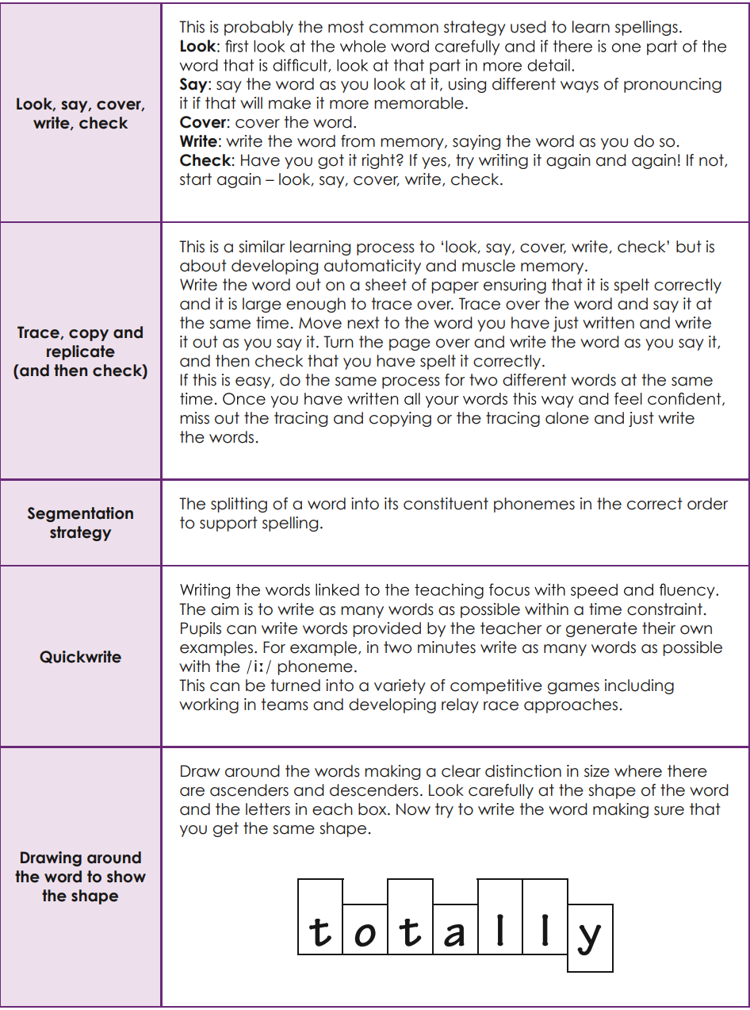No Nonsense methods for practising spellings: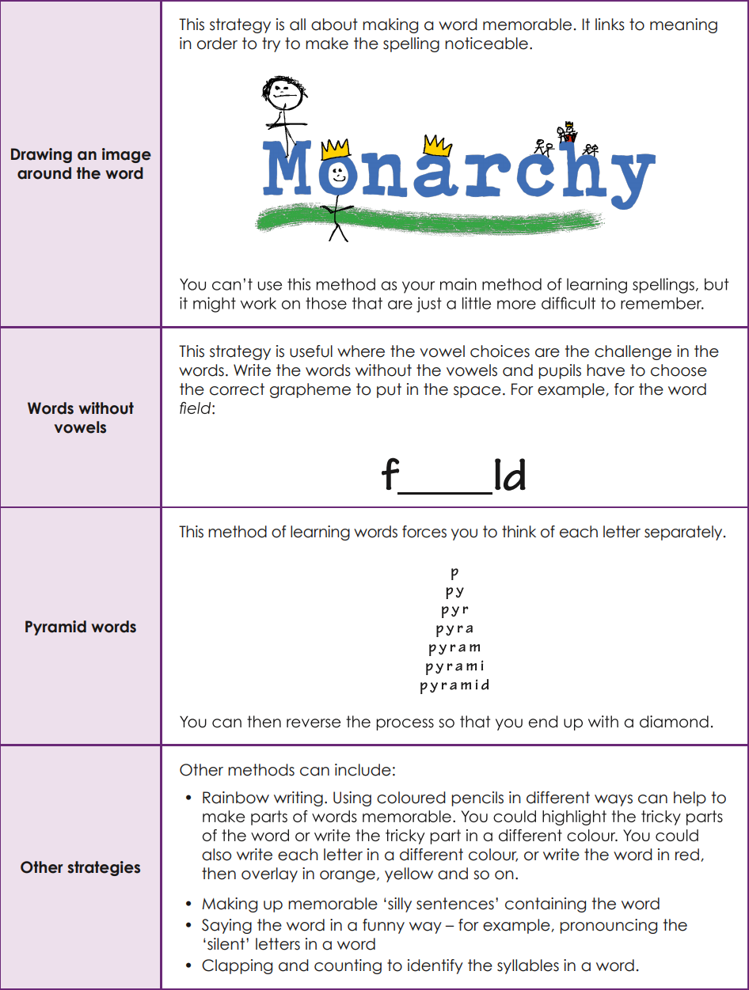

**7. Handwriting**

Children learn to use consistent, cursive handwriting through regular opportunities to practise with clear teacher modelling. In EYFS, children start by using print and only move on to a cursive style when they are secure (this is usually at some point during their time in KS1).

Letter formations are taught throughout EYFS and Year 1, then reinforced and consolidated in Year 2 and Key Stage 2. The formation of graphemes is taught alongside phonics and spelling programmes.

In Lower Key Stage 2 children begin to use a pen for writing, once they have demonstrated consistent, cursive handwriting.

**8. Assessment**

Phonics

* As well as ongoing formative assessments during lessons; end of phase assessments, TELL diagnostic tool and phonics screening checks are used to track children’s progress, inform planning, identify children who need further consolidation and organise groupings.
* At the end of Year 1 all children take the Phonics Screening test. Year 2 children who did not achieve the pass mark in the previous year re-take the Screening test at the same point in time.

Writing

* Teachers use the End of Year Expectations to assess writing (see below). These are stuck in the front of children’s writing books and are assessed after each piece of final writing. Teachers will tick off the standard that the child has met. This assessment is then used to inform the next steps in planning for writing lessons.
* Writing is internally assessed termly with year group moderation and cross phase moderation. In both meetings, teachers have the opportunity to discuss children’s work and their progress.
* In Year 2 and Year 6 the Teacher assessment frameworks at the end of key stage 1 and the end of key stage 2 are used for teachers to make statutory assessment judgements for pupils at the end of KS1 and KS2.
* <https://www.gov.uk/government/publications/teacher-assessment-frameworks-at-the-end-of-key-stage-2>
* <https://www.gov.uk/government/publications/teacher-assessment-frameworks-at-the-end-of-key-stage-1>

Reading

* Reading fluency is assessed whilst listening to children read. Children progress through the book bands based on their fluency and understanding of the text.
* In year 6, children are assessed termly using SATs papers from previous years.
* Reading is assessed termly in years 2-5 using NFER papers.
* Teachers track children’s progress using the Etchells Primary School Reading progression documents (see below).

