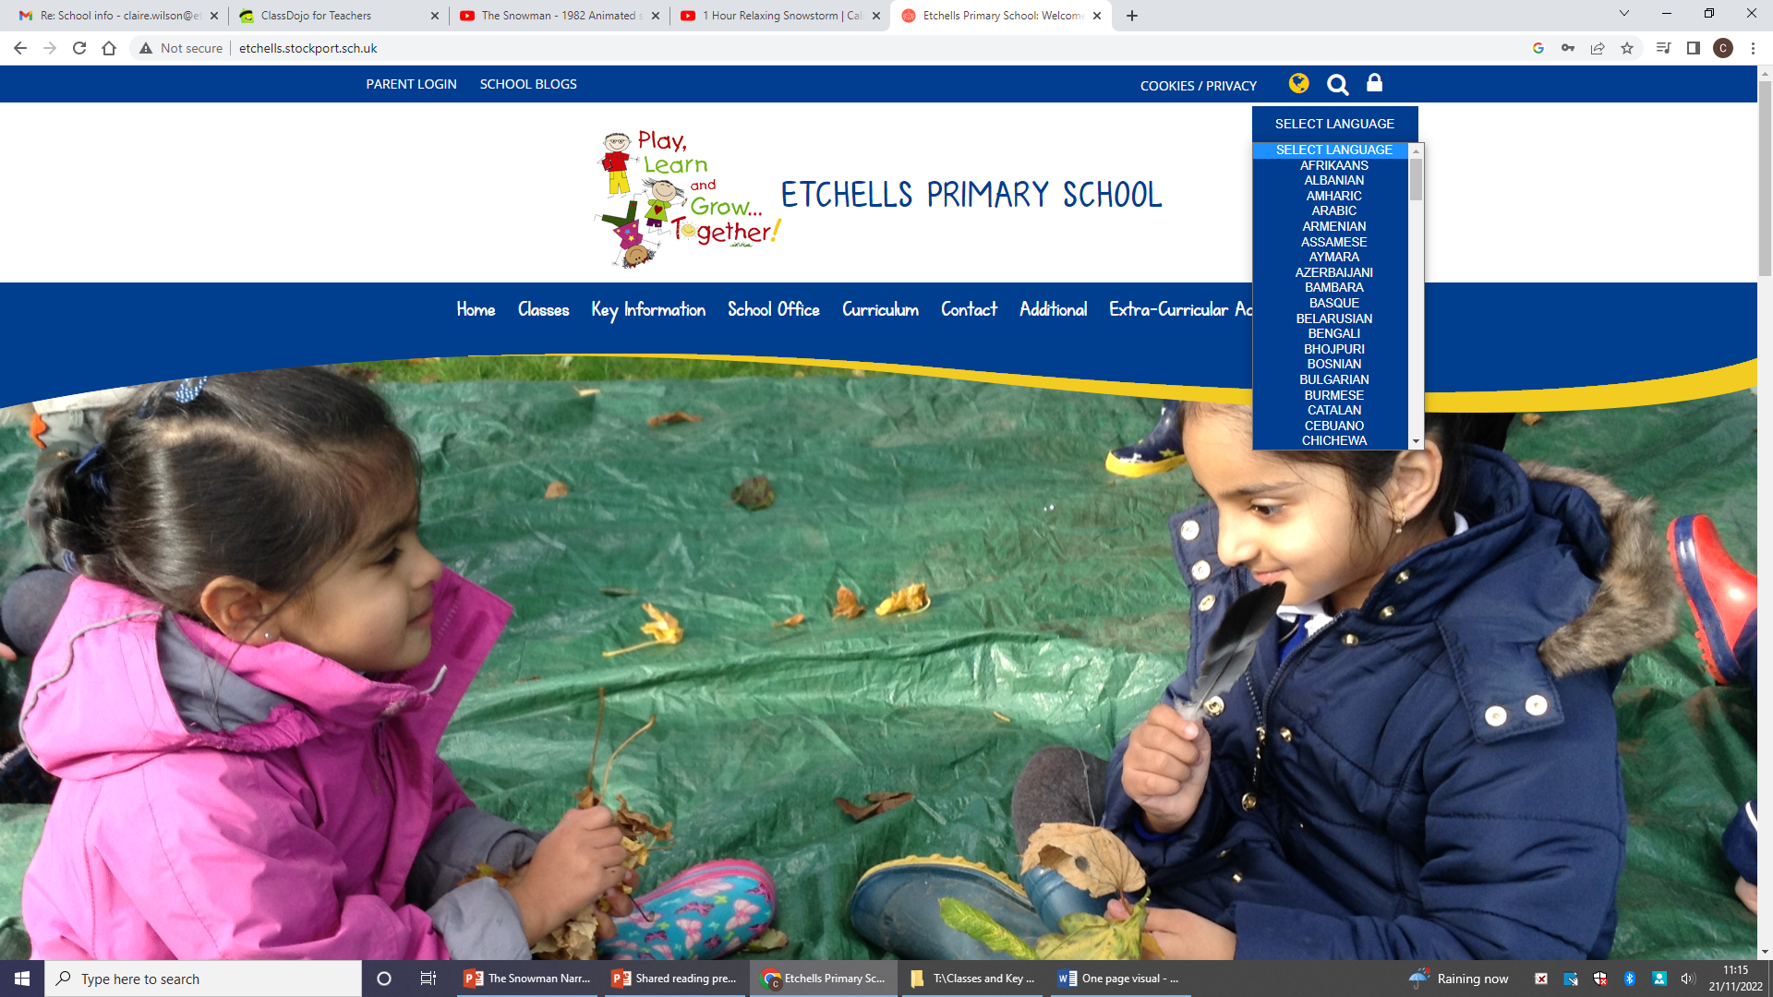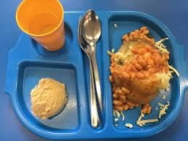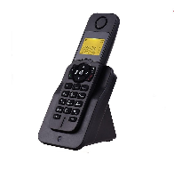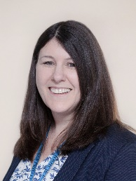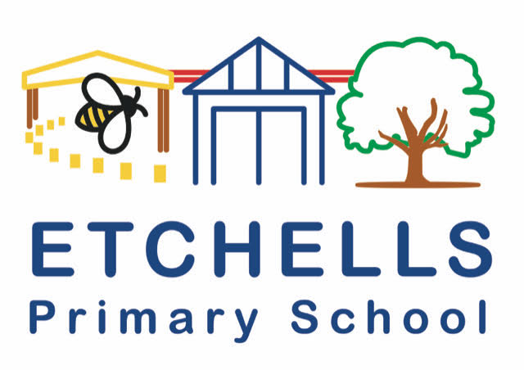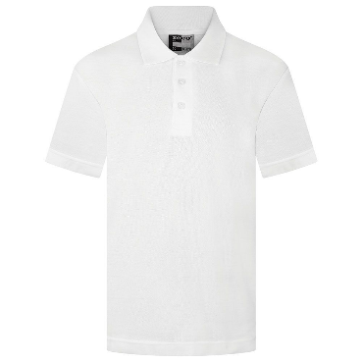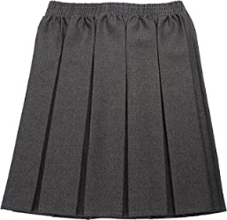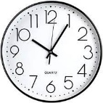

**Lunches:**

KS1: get a free school meal each

day.

KS2: £2.60 per day.

**Website:** Translation

**Communication:**

Class Dojo, Email or school

office.

Parents evening – twice a year

**Fruit Scheme:**

Children in EYFS and KS1 are

entitled to a free piece of

fruit each day.

day.

**Uniform:**

**Times:**

School Hours:

**8.50 a.m. to 3.15 p.m.**

Nursery Class Hours:

Monday, Tuesday, Thursday and Friday: 9am - 3.15pm

Wednesday morning:  9am - 11.30am

Wednesday afternoon:  12.45pm - 3.15pm

**Contact us:**

[0161 437 1792](https://www.google.com/search?q=etchels+praimry+school&rlz=1C1GCEU_enGB1024GB1024&oq=etchels+praimry+school&aqs=chrome..69i57j46i13i175i199i512j0i13i512l3j0i22i30l4.4769j0j9&sourceid=chrome&ie=UTF-8)

**Headteacher:** Mrs Beddows

**Email:** Headteacher@etchells.stockport.sch.uk