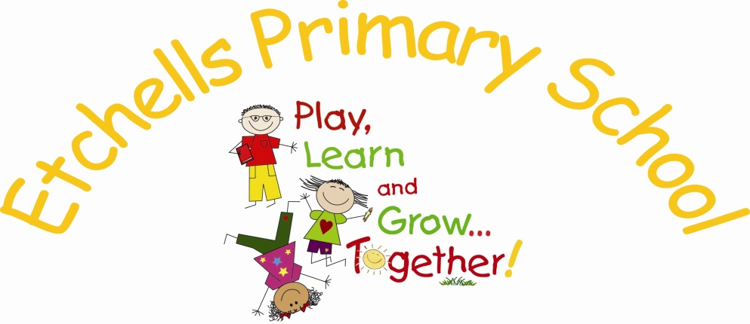

RE
POLICY

September 2017


 |    |  |   

ETCHELLS PRIMARY SCHOOL

AIMS AND OBJECTIVES

- To develop an understanding of the major world religions and the influence that their different religious beliefs, values, traditions and practices have on individuals, communities, societies and cultures.

- To appreciate, value and reflect upon their own, and other people's, beliefs and practices and express their own personal viewpoints in a thoughtful, reasoned and considerate way.

- To help children to develop as caring individuals as part of a larger community by fostering values such as: honesty, fairness, tolerance and respect for themselves and others.

- To recognise the right of people to hold different beliefs within a religiously diverse society.

This will be achieved by:
Etchells has chosen to follow the Chester Diocese syllabus as the basis of the planning and delivery of R.E, supplementing with additional units which cover the religious beliefs and practices of the major religions represented in Great Britain today: Christianity, Islam, Judaism, Hinduism, Buddhism and Sikhism.

Where possible an R.E. lesson should allow children to learn about a specific aspect of a religion or religions in addition to the opportunity to learn from it, by expressing their own beliefs and values.

Right of Withdrawal:

Where parents employ the right to withdraw their child from R.E., under the provisions of the 1988 Education Reform Act, teaching staff will make arrangements for the continuing learning of those children within the school. This, at present, is not applicable to any child within our school. If children are withdrawn from R.E. lessons then the Headteacher and Board of Governors will be informed.

Curriculum Coverage for R.E.
The children in the Foundation Stage are taught R.E. through the area of Knowledge and Understanding of The World. In KS1 and KS2 R.E. may be taught either discreetly or as part of a cross-curricular approach e.g. through PSHE, history, geography, art or as part of a focus day or period of time e.g. Christmas and Easter.

Religious Education is taught at least once a fortnight. It should be detailed on long term planning and can be provided as a separate subject or taught in combination with other subjects through cross-curricular learning.

This is the whole school long term plan which details the units covered:

½ Terms  Year Groups | Autumn 1 | Autumn 2 | Spring 1 | Spring 2 | Summer 1 | Summer 2
Reception | Christianity Unit R  Caring & Belonging  Harvest | Christianity Unit R  My Birth/Christmas | Christianity Unit R  Special Objects/Places | Christianity Unit R  New Life | Christianity Unit R  Friendship | Christianity Unit R  Important People/God
Year 1 | Christianity Unit 1  Creation  People who met Jesus | Christianity Unit 1  Baptism/Belonging  Christmas- Gifts for a baby | Christianity Unit 1  Stories of Love & Forgiveness | Islam  Family life | Christianity Unit 1  Church as a place of Worship | Buddhism  Symbols
Year 2 | Christianity Unit 1  Introduction to the Bible | Jesus’ Early Life & Ministry  Christmas Stories around the World | Christianity Unit 1  Jesus the Storyteller | Christianity Unit 1  Easter  Modern customs | Sikhism Family life and the Guru Granth Sahib | Judaism Unit 1  Jewish Stories
Year 3 | Christianity Unit 2  Why is the Bible important? | Christianity Unit 2  Jesus the Healer  Christmas -  Perspectives | Hinduism | Christianity Unit 2  The Wider Church | Islam Unit 1  Islam –Allah and Mohammed (PBUH)-stories | Specific Focus  Descriptions of God
Year 4 | Judaism Unit 2  Jewish Family Life | Christianity Unit 2 Christian Faith expressed through the Arts  Christmas – Giving to others | Buddhism | Christianity Unit 2  Caring for Creation  (2015 – Islam) | Specific Focus Religious Artefacts | Christianity Unit 2  Parables
Year 5 | Islam Unit 1,2  Islam-5 Pillars | Specific Focus  Sacred Texts  Christmas - angels | Judaism Unit 2  Sikhism  Places of Worship | Christianity Unit 2 Jesus’ Teaching & its impact on people | Christianity Unit 2  Worship | Christianity Unit 2  Places of Worship
Year 6 | Christianity Unit 2  Christian Values & Beliefs | Christianity Unit 2 Christian Charity  Christmas- comparison of narratives | Islam Unit 1,2  Hinduism | Christianity Unit 2  Life of Jesus | Judaism Unit 2  Jewish Values | Specific Focus  Faith in Everyday Life

Teaching and Learning

A variety of teaching methods should be used to teach RE, such as role play/drama, stories, art and music. Practical, creative, hands-on styles are encouraged.

Visits to places of worship are encouraged and visitors are welcomed, in order to give children the opportunity to listen to and ask questions about another person’s experiences of living/celebrating through different faiths. On these occasions, when necessary, risk assessments will be drawn up and parental permissions sought.

The Foundation Stage and KS1 form the basis of children’s future understanding and therefore should begin with children’s own experiences and feelings, particularly around ‘special times, people, places and objects/symbols. Many opportunities should be given for thinking, talking, listening and responding to others respectfully. Much emphasis should be placed on valuing and caring for other people in our local community and also for children to relate their understanding to a wider/global community.

In KS2, similar opportunities should be offered and children should be encouraged to openly discuss their understanding, opinions and attitudes about religion. They should be given time to reflect on what the religious ideas and concepts mean to them and promote their own spiritual growth and development.

It is important to note that the teaching of R.E. can support and underpin key British Values, defined by Ofsted as: democracy, the rule of law, individual liberty, mutual respect for and tolerance of those with different faiths and beliefs and for those without faith. Open and respectful discussions can also play a role in supporting teachers in carrying out their Prevent Duty in the classroom.

It is possible that a teacher may have their own religious beliefs/faith. The teaching of RE must not be used to indoctrinate or challenge children’s faiths/beliefs which may be different from their own. Teachers must be sensitive about the language that they use, for instance swapping, ‘I go to church on Sundays’ to, ‘Christians go to church on Sundays’.

Teaching staff will be encouraged to include R.E. within their homework tasks.

Special Needs
Pupils with diverse learning needs are provided for through:
- Teachers planning for the pupils full participation
- Setting high expectations
- Providing opportunities for all pupils to achieve
- Creating effective learning environments
- Providing equality of opportunity through teaching approaches
- Allowing pupils access to specialist equipment and approaches where necessary
- More able pupils are planned for appropriately
- This is supported by our equal opportunities policy

Assessment, Monitoring and Review
Assessment will form part of the teaching and learning of R.E. as it informs planning. Techniques include:
- Questioning and response during lesson time
- Observations and conversations with pupils at work
- Monitoring pupils written and pictorial work through topic book scrutiny (twice a year) and providing feedback to staff
- Hearing pupil’s views through Pupil Voice (twice a year) and feeding back suggestions to staff

Progress and effort are reported to parents at parents’ evenings and in end of year reports.

